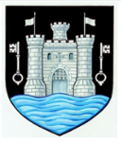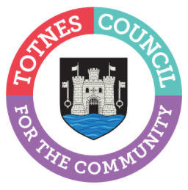

24 May 2024
TOWN COUNCILLOR ELECTION CONFIRMED FOR 20 JUNE 2024
Totnes Town Council has had confirmation from South Hams District Council that a by-election will be held on 20 June 2024 to find a new town councillor to represent Totnes Town Ward. Two candidates have been nominated for the role. A polling station at Totnes Civic Hall will be open from 7am-10pm so residents in Totnes Town Ward can cast their vote.
Three nominations have been received for co-option as a councillor to the Bridgetown Ward position. Town Councillors will review the applications and make an appointment at the Full Council meeting on 10 June 2024.

The Council is made up of 16 Councillors – 10 representing Totnes Town and 6 representing Totnes Bridgetown. The Council meet once a month at 6.30pm, in the Guildhall, Totnes, with additional committee meetings held throughout the year. These roles are voluntary.

-Ends
For more information, please contact Lucy Ferrier info@visittotnes.co.uk or call 01803 862147

