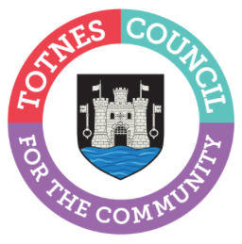

14 May 2024

TOTNES TOWN COUNCIL CONFIRMS 2024 MAYOR AND DEPUTY MAYOR
At the Full Council meeting on 13 May 2024, Cllr Emily Price was elected as Mayor of Totnes with Cllr Tim Bennett appointed as Deputy Mayor.
Cllr Emily Price commented: “I’m pleased to continue to serve as Mayor of Totnes for another year and hope that together we will all be able to make a positive difference for everyone who lives and works here. I’d also like to thank my fellow councillors who are continuing to serve the town.”
On Tuesday 21 May 2024, the traditional, formal Mayor Making Ceremony will take place at The Guildhall. This is a private event which will be followed by a procession by the Mayor and Deputy Mayor to St Mary’s Church.

2024 Totnes Town Council Councillors
- Cllr Luisa Auletta
- Cllr Chris Beavis
- Cllr Tim Bennett (Deputy Mayor)
- Cllr Jeff Chinnock
- Cllr Sarah Collinson
- Cllr Tom Cooper
- Cllr John Cummings
- Cllr Jill Hannam
- Cllr Jacqi Hodgson
- Cllr Darren Peters
- Cllr Anna Presswell
- Cllr Emily Price (Mayor)
- Cllr Nick Roberts
- Cllr Lisa Smallridge
- Vacancy Bridgetown Ward
- Vacancy Totnes Town Ward

Following the resignation of two councillors earlier this year, a co-option and an election are now scheduled to fill these vacancies. Residents have been invited to put themselves forward for the roles. The co-option for a town councillor (Bridgetown Ward) will be agreed at the Full Council meeting on 10 June 2024. An election for a new town councillor (Totnes Town Ward) is expected to take place in June (date to be announced).
More details on councillors, and the groups and committees they are standing on, can be found here: www.totnestowncouncil.gov.uk/your-council/your-councillors/ Residents have a chance to meet the councillors and ask questions at the upcoming Town Meeting. This takes place at 5pm on Wednesday 29 May 2024 in the Civic Hall.

-Ends
For more information, please contact Lucy Ferrier info@visittotnes.co.uk or call 01803 862147

