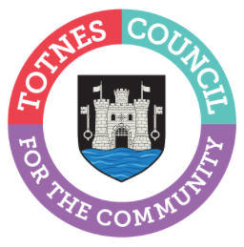

9 January 2024
TOTNES TOWN COUNCILLORS CALL FOR AN IMMEDIATE CEASEFIRE

At their meeting on 8 January 2024, Totnes Town Councillors formally agreed to write to Anthony Mangnell, Rishi Sunak, and Keir Starmer to call for an immediate ceasefire between Israel and Hamas in Gaza, as outlined in the open letter below:

We are writing to you as Totnes Town Councillors to express the outrage we are all feeling over the appalling events taking place in Gaza and to ask that you call on the UK Government to do everything in its power to secure an immediate ceasefire and work towards a peaceful settlement of this conflict.

The killing and kidnapping of Israeli citizens by Hamas have rightly sparked global outrage and have been called out by Human Rights Watch and others as war crimes. But with the wholesale destruction of entire towns and cities, the bombardment of civilian targets, the forcible transfer and indiscriminate slaughter of the civilian population and obstruction of humanitarian aid, there is widespread consensus that war crimes are also being committed in Gaza. The atrocities committed by Hamas do not justify the collective punishment and other violations of international humanitarian law by the Israeli Government against the Palestinian civilian population in Gaza; international law is clear on the fact that violations by one party to a conflict can never justify violations by another.

Furthermore, it is clear that the Israeli Government’s extreme and disproportionate aggression against Gaza’s civilian population will only fuel continuing grievance and violence for decades to come and will ultimately achieve nothing for Israel’s stated aim to destroy Hamas.

There is simply no credible self-defence justification, in legal or strategic terms, for Israel’s continuing perpetration of war crimes against Palestinians.

As Totnes Town Councillors, we call on the UK Government to halt any exports of weapons from the UK to Israel, and to press all parties to the conflict to agree: (i) to an urgent permanent ceasefire in Gaza, Israel and the rest of Palestine and to make every effort to resume the peace process; (ii) to guarantee that international humanitarian law is upheld and that civilians are protected in accordance with those laws; (iii) to ensure that civilians have access to humanitarian support, including unfettered access of medical supplies, food, electricity, other fuel and water.

-Ends
For more information, please contact Lucy Ferrier info@visittotnes.co.uk or call 01803 862147

