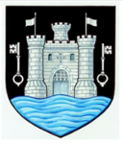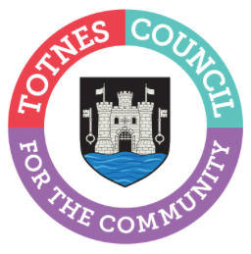

5 December 2023

TOTNES BUSINESSES LIGHT UP THE TOWN

Totnes Town Council has announced the winners of its Business Christmas Window competition and thanked them for their role in helping to make Totnes look so festive this year. Penelope Tom took the honours for the best window below Eastgate Arch and Fox and Co was awarded the accolade for the best window above the Arch. Oliver’s Butchers scooped the win for the best decorated building frontage. 29 local businesses entered the Town Council-organised competition, which was devised to accompany the Town Council’s investment in a new Christmas lighting scheme to bring cheer to local people and visitors and help boost businesses. Each of the deserving winners received £100 (£75 for second place and £50 for third place). Judging took place on Monday 4 December with Totnes Mayor, Cllr Emily Price, joined by Cllr Tim Bennett (Totnes Town Council Link Cllr for the Chamber of Commerce) and his two children, as well as Sarah Kidd from the Chamber of Commerce.

Cllr Emily Price commented: “I’d like to thank all the businesses that entered our festive window competition – we are blown away by the creativity and fun in each and every window. It made choosing the winners an incredibly hard job. And it’s not just the businesses that entered the competition that I’d like to thank - it feels like this Christmas even more businesses and residents have pulled out all the stops creating a town-wide spirit of festive togetherness, so thank you everyone! You’ve really helped to make Totnes an extra magical place to visit this Christmas – and that’s got to be good for our local economy and us all!”

Last week, Totnes Town Council turned on their new festive lights on the Market Square Christmas Tree and around the town at the Plains, the Shady Garden, the front of the Eastgate Arch, the Civic Hall, and in The Rotherfold. The Chamber of Commerce has also installed festoon lights above the road at various points in the town. Together with the window displays in shops, Totnes Town Council hopes the Council’s investment in festive lights this year will not only share a little extra festive joy with local people and visitors but it will also help to give businesses in the town a welcome financial boost.

Winning businesses:
Below Eastgate Arch
1st – Penelope Tom
2nd – Fonehouse
3rd – Out of the Blue

Above Eastgate Arch:
1st – Fox and Co
2nd – Me and East
3rd – A Pickled Thought

Best decorated building frontage:
1st - Oliver’s Butchers
2nd – Fifty5a
3rd – The Mansion

-Ends
For more information, please contact Lucy Ferrier info@visittotnes.co.uk or call 01803 862147

